Please wait for verbal instructions…

I
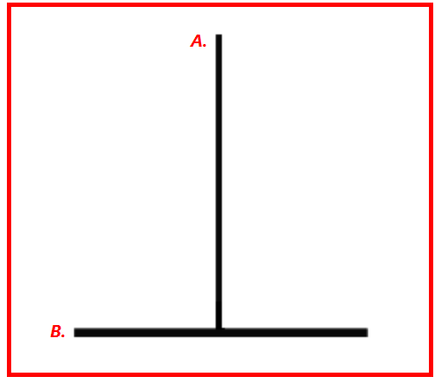 | DOORSTWW

